Project: Bouncing Ball Game on Scratch
Class: Bs Cs
Section: B
Semster:1ST
Submitted to: Sir Abdul Ghani
Subject: ICT
Group no: 7
Team members:
- Musa bin Abdullah (233576) team leader
- Hassan Ali (233542)
- Ali Asif (233562)



Introduction:
The Bouncing Ball Game is a dynamic and engaging project developed on the Scratch platform. This game combines user interaction, programming logic, and visual design to create an entertaining experience for players.
Key Features:
1. Player Controls: Users navigate the game using the arrow keys, providing a simple and intuitive interface for players of all ages.
2. Bouncing Physics: Realistic bouncing mechanics simulate the natural movement of a ball, enhancing the game's realism and immersion.
3. Score System: Points are awarded for every successful bounce, motivating players to achieve higher scores and challenge themselves.
4. Dynamic Background: The game features a visually appealing background that changes as the player advances, creating a sense of progression.

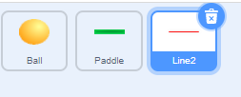
Programming Elements:
1. Motion Blocks: Utilized to control the movement of the ball in response to user input.
2. Event Handlers: Triggered by keyboard input, these events enable smooth gameplay and responsive controls.
3. Variables: Used to keep track of the player's score and adjust game difficulty as needed.
4. Conditional Statements: Implemented to detect collisions with the screen edges and respond accordingly, preventing the ball from going off-screen.
Challenges Faced:
1. Score Tracking: Implementing a robust scoring system involved managing variables and updating them dynamically during gameplay.
2. User Interface Design: Balancing visual appeal with simplicity was a challenge to create an engaging yet accessible gaming experience.
Coding steps:
- To move the scratch of the ball I added the direction to 90 degrees.
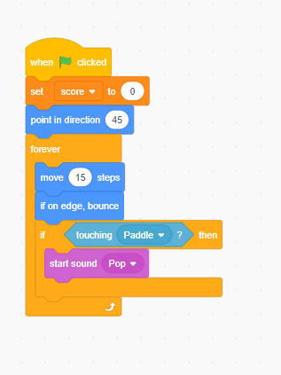
- Then forever loop to make it run 15 steps continuously.

- I added if statement in the program so that if the ball touches the paddle, then it should produce a sound.

- Sound of popping was added.

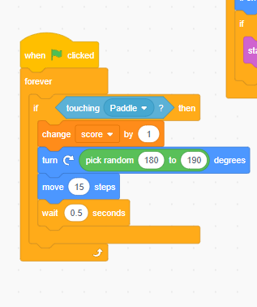
- To run the ball in random direction I added the turn statement and random statement from 160 degrees to 180 degrees so that the ball should not move towards the red line after touching the paddle which makes it as game over.

- I put the code in forever loop so that the code should run in forever until the user touches red line and game over.

- I also used a user defined variable to count the score in it.

- And the score resets itself after the game ends when the ball touches the red line.

- And if the score increases more than 15 the user wins the game.
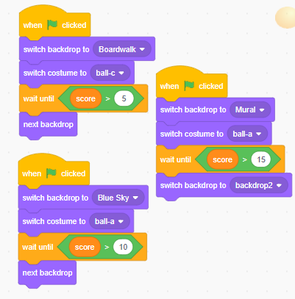
- So, to make it more fun I added two backdrops so that after reaching a certain score the backdrop or background would change itself automatically.

- This was done by adding inequalities.

- And would increase the speed after change in background as next backdrop.by increasing steps to 20.

- I also switched costumes too to attract the user and make it more fun by switching statement.

- Here is the remaining code for the game as the ball touches the red line, the paddle and ball disappears and a screen of game over appears.

Conclusion:
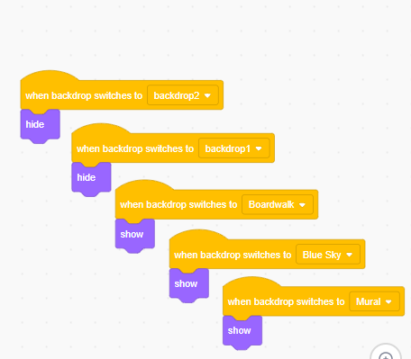
The Bouncing Ball Game on Scratch successfully combines programming principles with an interactive and visually appealing user experience. Its intuitive controls and dynamic gameplay make it an enjoyable project for both creators and players, showcasing the potential of Scratch as a platform for game development.

Results:
